
RAMAIAH
Institute of Technology
USN | 1 | M | S

(Autonomous Institute, Affiliated to VTU)
(Approved by AICTE, New Delhi & Govt. of Karnataka) Accredited by NBA & NAAC with ‘A’ Grade

SUPPLEMENTARY SEMESTER EXAMINATIONS – AUGUST 2019

Course & Branch | : | B.E: Electrical and Electronics Engineering | Semester | : | V
Subject | : | Control Systems | Max. Marks | : | 100
Subject Code | : | EE52/EE502 | Duration | : | 3 Hrs

Instructions to the Candidates:
- Answer one full question from each unit.

 |  | UNIT-I
1. | a) | Obtain the transfer function of the following mechanical system.  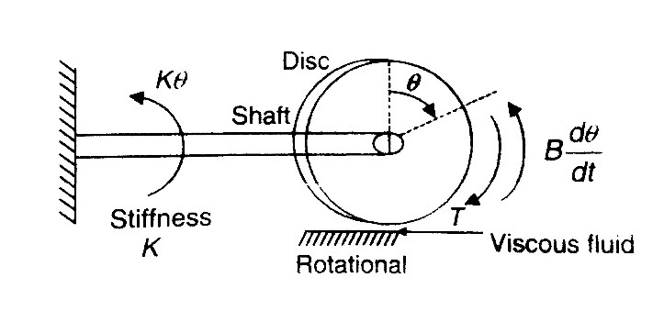  Fig.1(a) | CO1 | (10)
 | b) | What are the advantages of having feedback over an open loop, in a control system?. Explain with at least 2 examples with respective block diagrams. | CO1 | (10)
2. | a) | Obtain the transfer function of the following system. If the inductance 'L' is replaced with another resistor, whether output leads or lags? Justify your answer.  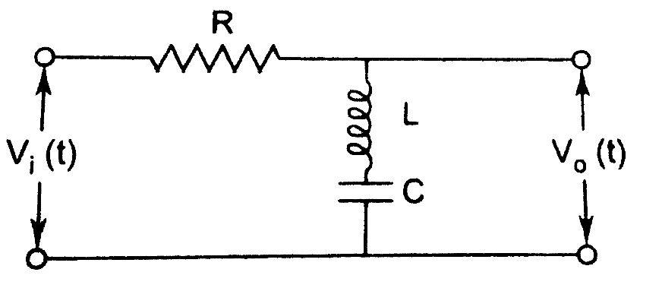  Fig. 2(a) | CO1 | (08)
 | b) | Obtain the transfer function for the following system. Also draw, i) F-V and ii) F-I analogous circuit of the following mechanical system given in Fig. 2(b).  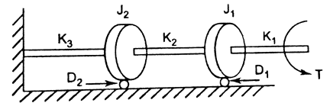  Fig. 2(b) | CO1 | (12)
 |  | UNIT- II
3. | a) | For a unity feedback system 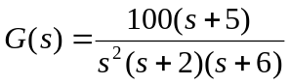 find (i) type of the system (ii) error coefficients (iii) steady state error for input 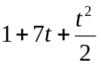. | CO1 | (08)
 | b) | What is meant by steady-state error? Derive an expression for steady-state error of a unity negative feedback system. | CO2 | (04)
 | c) | A second order system is represented by the transfer function, 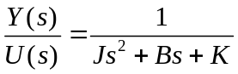. A step input of 10Nm is applied to system and results are,  - % 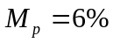  - 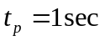  - The steady state value of output is 0.5 radians.  Find the values of J,B and K. | CO2 | (08)
4. | a) | Reduce the following block diagram to a single transfer function. Fig. 4(a)  i) 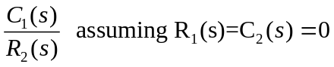  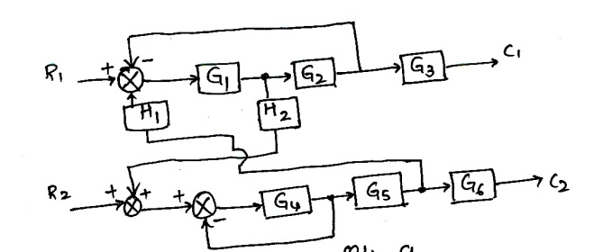  Fig. 4(a) | CO2 | (08)
 | b) | Derive an expression for time response 'c(t)' of a standard 2nd order under damped system. | CO2 | (08)
 | c) | Define the Stable System? If a closed loop TF is having zero at -2 and poles at -3, +5, whether system is Stable? Justify with its time response behavior. | CO3 | (04)
 |  | UNIT- III
5. | a) | State and explain RH criterion of stability and its limitations? Hence Examine the stability of the given equations using Routh’s stability criterion:  - ii) | CO3 | (08)
 | b) | Plot the root locus of the system with OLTF 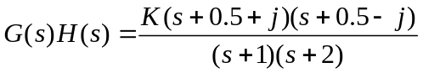, Show that part of root locus of system is a circle. | CO3 | (12)
6. | a) | How the change in system gain affects stability of the system? Briefly explain relevant mathematics with an example. | CO3 | (08)
 | b) | A system having OLTF 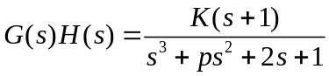, oscillates with frequency 2 rad/sec. Find values of ‘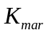’and ‘p’ if system is stable. | CO3 | (12)
 |  | UNIT- IV
7. | a) | Can we interpret the time domain behavior of the system based on frequency response? Justify your answer with relevant relations. | CO4 | (06)
 | b) | Sketch the Nyquist plot and determine the stability of the following open loop transfer function of unity feedback control system 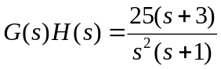 . Comment on stability. | CO4 | (14)
8. | a) | Check the closed loop stability of the following open loop system on GH plane using conformal mapping technique by considering entire right half of s-plane as reference.  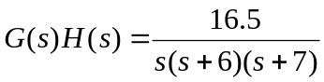 | CO4 | (10)
 | b) | Using Nyquist stability criterion, investigate the stability of closed loop system whose OLTF is 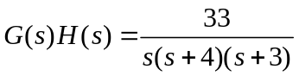. | CO4 | (10)
 |  | UNIT- V
9. | a) | For a unity feedback system, the open loop transfer function is 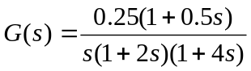. Draw the log magnitude plot and the phase plot and determine:  - the gain cross over frequency  - the phase margin  - the phase cross over frequency  - the gain margin. | CO4 | (12)
 | b) | Explain the procedure for lag compensation. | CO5 | (08)
10. | a) | Design a lead compensator for a unity feedback system with open loop transfer function 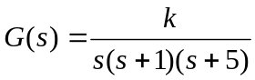 to satisfy the following specifications :  - Kv >50 (ii) Phase Margin is >20 | CO5 | (12)
 | b) | Explain the concept of phase margin & gain margin? | CO4 | (08)

****************

